**AirShare**

**A Mini-Project Report**

**Under**

**Implementation Of Technology**

***Submitted by***

**Rohan Menon(E001)**

**Sai Nadkarni(E002)**

**Shiv Tomar(E013)**

**Neelansh Prasad(E014)**

***Under The Guidance Of***

**Prof Poonam Gupta**

***in partial fulfillment for the award of the degree***

***of***

**B. Tech**

**in**

**Computer engineering**

**at**



**Mukesh Patel School of Management & Engineering**

**April 2016**

**CERTIFICATE**

This is to certify that the project entitled **AirShare** is the bona fide work carried out by **Shiv Tomar, Sai Nadkarni, Rohan Menon and Neelansh Prasad** B.Tech (Computer Engineering), MPSTME (NMIMS), Mumbai, during the fourth semester of the academic year 2015-2016, in fulfillment of the requirements for the award of the Degree of Bechelors of Technology as per the norms prescribed by NMIMS. The project work has been assessed and found to be satisfactory.

___________________

Prof. Poonam Gupta

Internal Mentor

_______________________ ________________________

Examiner 1 Examiner 2

________________________

Dean

Dr. Sharad Y. Mhaiskar

**DECLARATION**

We, **Rohan Menon, Sai Nadkarni, Neelansh Prasad and Shiv Tomar** B.Tech (Computer Engineering), semester- IV, understand that plagiarism is defined as anyone or combination of the following:

1. Un-credited verbatim copying of individual sentences, paragraphs or illustration (such as graphs, diagrams, etc.) from any source, published or unpublished, including the internet.

2. Un-credited improper paraphrasing of pages paragraphs (changing a few words phrases, or rearranging the original sentence order)

3. Credited verbatim copying of a major portion of a paper (or thesis chapter) without clear delineation of who did wrote what.

4. We have made sure that all the ideas, expressions, graphs, diagrams, etc., that are not a result of our work, are properly credited. Long phrases or sentences that had to be used verbatim from published literature have been clearly identified using quotation marks.

5. We affirm that no portion of my work can be considered as plagiarism and we take full responsibility if such a complaint occurs. We understand fully well that the guide of the seminar/ seminar report may not be in a position to check for the possibility of such incidences of plagiarism in this body of work.

Signature of the Students:

___________ ____________ ___________ ____________

Name**: Rohan Menon, Sai Nadkarni, Neelansh Prasad and Shiv Tomar**

Roll No.E001, E002, E013

Place: Mumbai

Date:

**Acknowledgements**

We would like to acknowledge our IOT mentor, Prof. Poonam Gupta for guiding us at every step of our project. We would also like to thank the Dean of Mukesh Patel School of Technology, Management and Management, Dr Sharad Mhaiskar for giving us this wonderful opportunity to make this app by ourselves and promote the culture of self learning.

**Table of contents**

**CHAPTER NO. TITLE PAGE NO.** Abbreviations 6

Abstract 7

List of Tables 12

List of Figures 14-19

1. INTRODUCTION

1.1 Project Overview 8

1.2 Why use this app? 8

1.3 Characteristics 8

1.4 Implementation 8

1.5 Hardware Specification 9

1.6 Software Specification 9

2. REVIEW OF LITERATURE 10

3. ANALYSIS & DESIGN 11

4. METHODS IMPLEMENTED 12

5. RESULTS & DISCUSSION 14

6. CONCLUSION & FUTURE SCOPE 18

7. REFRENCES 19

APPENDIX

**Abbreviations:**

|  |  |  |
| --- | --- | --- |
| **Abbreviations** | **Full Form** | **Description** |
| SDK | Software Development Kit | A **software development kit** is typically a set of software development tools that allows the creation of applications for a certain software package, software framework, hardware platform, computer system, video game console, operating system, or similar development platform. |

**ABSTRACT**

App Idea: Facilitating seamless transfer of files between an Android device and a PC equipped with a browser. The idea is to use the phone’s WiFi radio to create a local webserver.

Our app is AirShare. Our app is made for Android phones and tablets.

Why Android over any other platform? As quite evident, Android is the most widely used platform and is available to almost all mobile manufactures. Thus, considering its benefits and ease of use in mind, Android platform is the most suitable to consider.

Our idea is to make a user-friendly Android application that helps people to share files easily between a pc and an android device.

The objective of the app is to transfer files from a pc to a mobile or vice versa.

The app allows a user to transfer files without the need of a USB cable or even internet access. The phone just needs to be connected to the same local network as the client PC for the app to work.

The further document emphasizes on the importance and implementation of AIRSHARE.

**Salient Features of the app**

**User Friendly:** This application is user friendly because all the user needs to do is to enter the IP of the pc on the app. Once this is done they can easily transfer the files.

**Ease of Access:** This application saves time and minimizes the use of USB cords and different storage devices.

**INTRODUCTION**

**1.1 Project Overview**

In Today’s world we have many upcoming applications on every platform like iOS, Android, Windows and Blackberry etc. Our app is made for Android phones and tablets.

Why Android over any other platform? As quite evident, Android is the most widely used platform and is available to almost all mobile manufactures. Thus, considering its benefits and ease of use in mind, Android platform is the most suitable to consider.

There is always a need to transfer files between a PC and our trusty Android device. Maybe it’s for taking a backup of scanned photos of a test paper, or sending photos captured by the powerful cameras in our phone to be enjoyed on the big screen, there is always a scenario in which AIRSHARE will come in handy.

**1.2 Why use this app?**

AirShare makes your multi-screen life easier and more focused by helping you access and manage your phone from any computer, anywhere.

**1.3 Characteristics**

**User Friendly:** This application is user friendly because all the user needs to do is to enter the IP of the pc on the app. Once this is done they can easily transfer the files.

**Ease of Access:** This application saves time and minimizes the use of USB cords and different storage devices.

**1.4 Implementation**

1. **The UI:** The user interface should be smooth, fast and easy to use so that anyone can use it and it doesn’t take much of their time.

**1.5 Hardware Specification**

* Optimized for any screen size.
* RAM requisite: 512 MB

**1.6 Software Specification**

* Ice Cream Sandwich Version 4.0
* Application size: ~5 MB
* The Android Studio software SDK v19 and build Tool v19.2.0.

1. **REVIEW OF LITERATURE**

We have selected this app for development because we wanted to come up with something that solved the everyday problems of students in our college.This app dwells upon the issue that college students are facing a lot of problems regarding file transfer because carrying usb cords and hardrives are tiresome.

Thus we aim to help everyone with our app where file sharing is made easier.

We hope to increase the productivity of our app further, by adding many different features like transferring files on other OS other than windows, transferring files even when not connected on the same Wifi and also make it more platform friendly like iOS.

The app works by asking the user to enter the IP of the PC which holds the file. The user can view all the folders on the mobile phone on their PC. The user just has to select and click the file which needs to be downloaded.

1. **ANALYSIS & DESIGN**
2. **METHODS IMPLEMENTED**
3. **Getting IP address of connected network**
4. **Implementing a basic webserver**
5. **FTP**
6. **Assigning a port to the webserver**
7. **Successful destruction of created webserver upon app exit to prevent excessive resource drain**

**RESULTS & DISCUSSION**

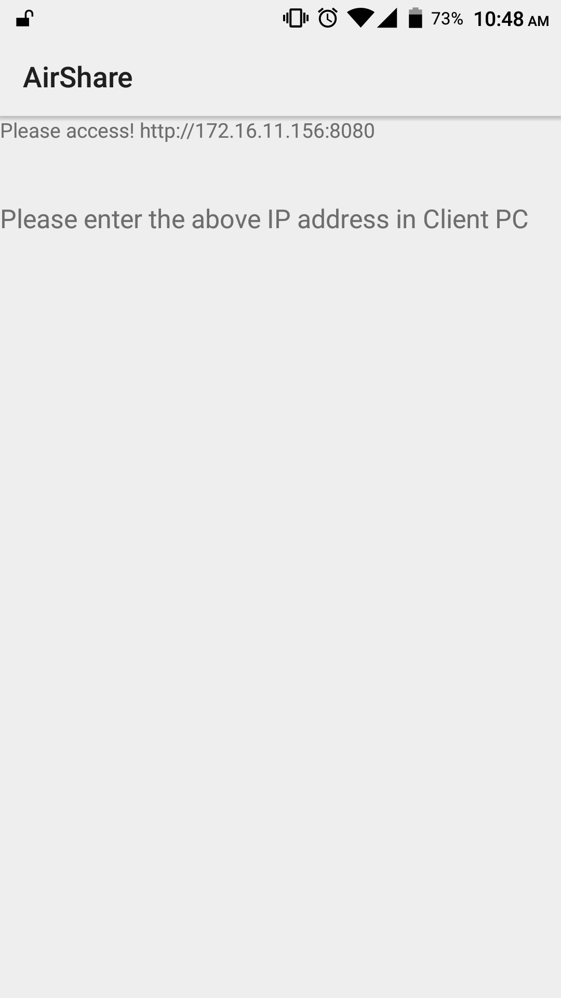

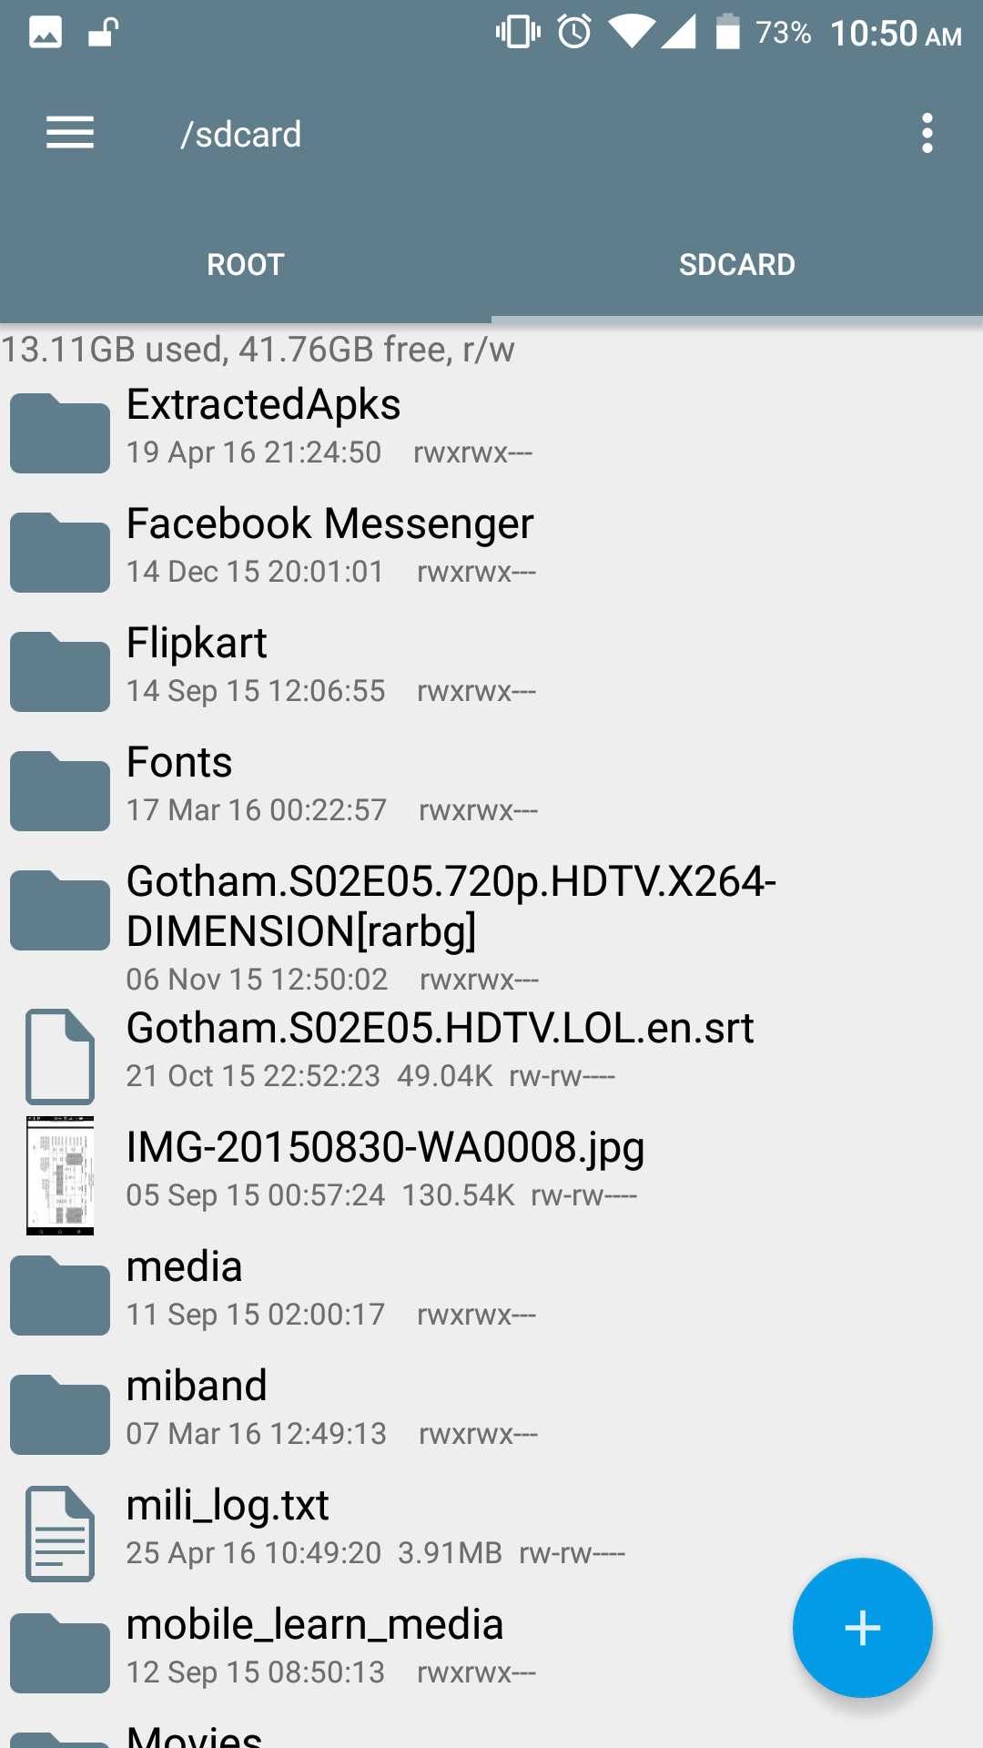

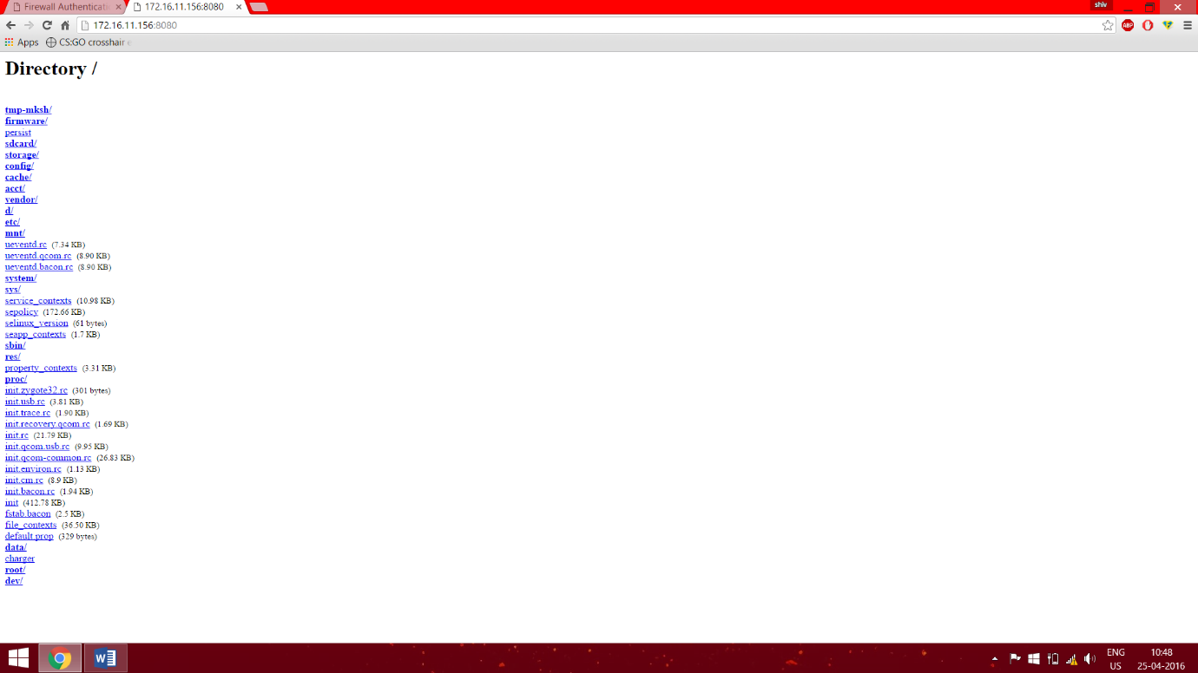

**CONCLUSION & FUTURE SCOPE**

AIRSHARE is a tool which can be very helpful in situations where there is an urgent need to transfer files but there isn’t a single USB cable to rely on. Moreover, any decent router is capable of providing the same transfer speeds as a standard USB 2.0 interface will provide,faster in most cases. It really is the better way for a phone and a PC to communicate without the added need of wires.

The functionalities of the app can be extended to even provide SMS support over the webserver. The user can write an SMS on the HTML webpage which is the standard one for the file transfers,and the app will make sure the SMS is sent to the specified contact.